**Дата**: 24.04.2025

**Клас**: 5-А

**Предмет**: англійська мова

**Тема:** Контрольна робота №7.

**Мета:** формувати навички вживання лексичних одиниць по темі; удосконалювати навички читання, аудіювання й усного монологічного мовлення; розвивати пізнавальні інтереси учнів; виховувати інтерес до самостійного пошуку потрібної інформації, а також загальну культуру учнів.

**Вчитель**: Руда Д.В.

Хід уроку

1.Greeting

Good afternoon, guys! I’m pickled pink to see you. Are you ready to start our lesson? All set?

2. Повторення

Повторити Irregular verbs .

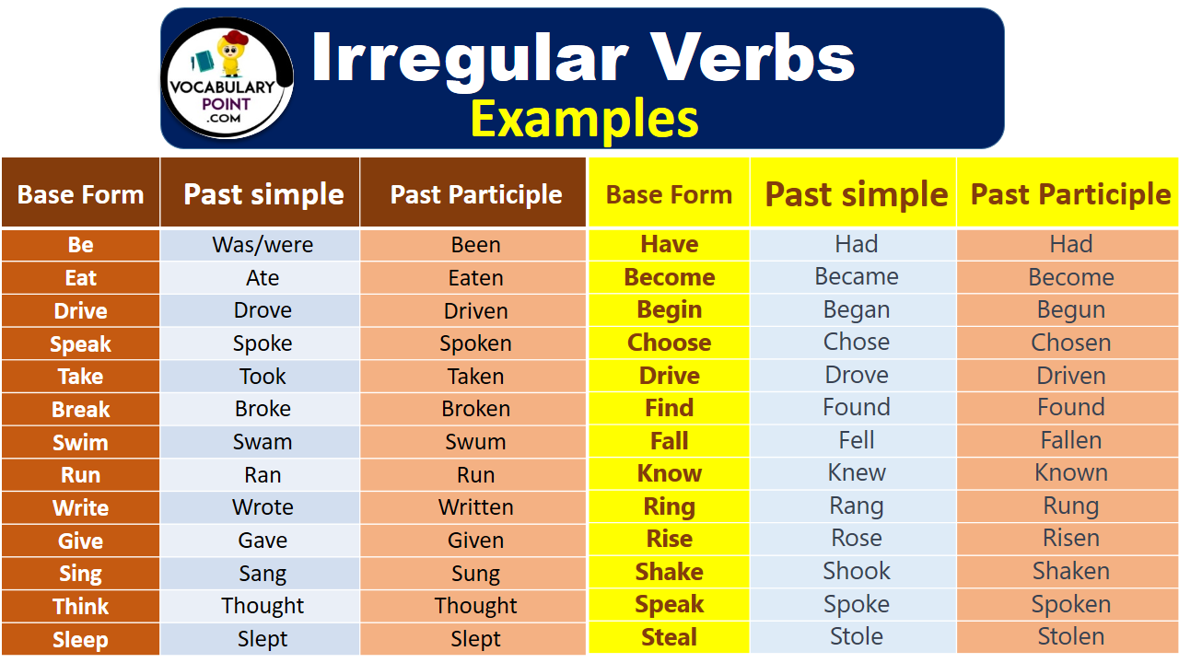

***Вивчити словник (бути готовим до слоникового диктанту) :***

*Careful-обережно (кеафул)*

*Slippery-слизько (сліпері)*

*To put on- одягати (пут он)*

*Overcast: covered with clouds; no sun is visible.- похмуро, сонця нема (овекаст)*

*"Under the weather": feeling ill or in low spirits. (e.g., "I'm feeling a bit under the weather today, so I'll stay home from work.")- мати погане самопочуття ( анде за везе)*

.

*Drizzle-мряка(дрізл)*

*Showers- a [short](https://dictionary.cambridge.org/dictionary/english/short" \o "short) [period](https://dictionary.cambridge.org/dictionary/english/period" \o "period) of [rain](https://dictionary.cambridge.org/dictionary/english/rain" \o "rain) or [snow](https://dictionary.cambridge.org/dictionary/english/snow" \o "snow)*

*Downpour- a lot of [rain](https://dictionary.cambridge.org/dictionary/english/rain" \o "rain) in a [short](https://dictionary.cambridge.org/dictionary/english/short" \o "short) [time](https://dictionary.cambridge.org/dictionary/english/time" \o "time) (дайн пор)*

*Flood-повінь(флад)*

*Hail-град(хейл)*

*Sleet-мокрий сніг(сліт)*

*Snowflake-сніжинка(сноуфлейк)*

*Blizzard-хуртелиця (блізард)*

*Mild: moderate in temperature; neither hot nor cold- помірний, м’який (майлд)*

*"Every cloud has a silver lining": every bad situation has some positive aspect to it. (e.g., "I lost my job, but I found a better one soon after. Every cloud has a silver lining.")- нема лиха без добра( ідіома)*

*To expect-очікувати(експект)*

*To report-повідомити(ріпот)*

*Chilly-прохолодний(чілі)*

*To get cold-холоднішати*

*It`s raining cats and dogs-сильно дощити (ідіома)*

*They cancelled the football game because it was raining cats and dogs.*

3. Wаrm up / Listening

Уважно слухати аудіо трек і дати відповідь на питання вчителя <https://www.youtube.com/watch?v=WuMEqV8Sbe4> .

4. Speaking

|  |  |
| --- | --- |
| 1) | What do you like to do in spring that you can’t do at other times of the year? |
| (2) | Does spring make you look forward to the year? |
| (3) | How would you feel if there wasn’t spring? |
| (4) | What does spring the season have in common with ‘spring’ the verb? |
| (5) | Would you like it to be spring forever? |
| (6) | What’s your favourite spring memory? |
| (7) | What clothes do you like to wear when spring arrives? |
| (8) | Do you think spring feels differently to people of different ages? |
| (9) | What adjectives would you use to describe spring? |
| (10) | "Spring shows what God can do with a drab and dirty world." ~ Virgil A. Kraft. Do you agree? |

5. Writing

Виконати контрольну роботу.

Control Work Unit 7 "The place I live in"

**1.Переклади українською**

1. Have you ever been to the Carpathians?
2. Has she ever read a book in English?
3. Have they ever made borshch on their own?
4. Has he ever seen a traditional Ukrainian wedding?
5. Have you ever danced hopak?

**2. Встав пропущені дієслова у правильній формі**

1 … did done

2 have … had

3 say said …

4 make … made

5 see saw …

6 … drank drunk

7 eat ate …

**3.Обери правильну форму дієслова з дужок. Звертай увагу на часові підказки (time markers).**

1. I _______ (eat) lunch already.
2. Yesterday she _______ (see) a beautiful rainbow.
3. We _______ (not finish) our homework yet.
4. He _______ (make) a cake last Saturday.
5. They _______ (never/be) to the Carpathians.
6. My brother _______ (drink) too much coffee this morning.
7. _______ you ever _______ (try) varenyky?
8. My parents _______ (have) a small house when I was little.
9. I _______ (not/do) my project yet.
10. She _______ (say) something funny a few minutes ago.

4. Complete the text: **history, capital, well-known, chestnut, talented, city, hard-working, are proud of, took its name after, is famous for.**

Kharkiv is the second largest …(1) in Ukraine. It was the … (2) of Ukraine in 1919-1934. The city …(3) the river it is on. Kharkiv is a beautiful green city with lots of … (4) trees along streets. The city’s monuments, churches and towels tell us a lot about the … (5). The city …(6) its National University. Kharkiv region is … (7) for its … (8) and … (9) people. They … (10) their city.

6. Homework

1. Пройти тест (на повторення) на платформі [join.naurok.ua](http://join.naurok.ua/)

Код доступу 6705999

2. Повторити слова у словнику.